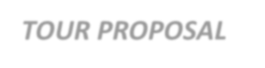 ***TOUR PROPOSAL***

|  |  |
| --- | --- |
| **Name of the client** | **C&K 7D/6N – MONO ITALY PROMO 2019** |
| **Nationality** | **Indonesian** |
| **Date of proposal** | **April, 2018** |
| **Name of the Group** | **C&K 7D/6N – MONO ITALY PROMO 2019** |
| **Tentative Travel date** | **Winter & Summer rates 2019** |

# RATES FOR NOV-EARLY DEC :

|  |  |  |
| --- | --- | --- |
| **SLAB** | **FOC** | **Twin/Dbl Sharing**  **(per person)** |
| **15-19 PAX** | **01 free in single** | **EUR 675** |
| **20-24 PAX** | **01 free in single** | **EUR 585** |
| **25-29 PAX** | **01 free in single** | **EUR 545** |
| **30-34 PAX** | **01 free in single** | **EUR 515** |
| **35-39 PAX** | **01 free in single** | **EUR 500** |
| **40-44 PAX** | **01 free in single** | **EUR 485** |
| **Single Supplemen** |  | **EUR 195** |

*Slab pricing is based on Full Paying Adults*

# ITINERARY

**Day 01 ARRIVAL ROME, FREE TIME (-/D) (Rome)**

Pick up at The Airport

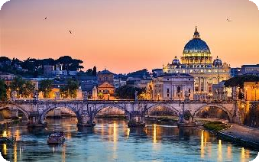

Transport for full day disposal without guide Lunch under own arrangement

Dinner at Restaurant Overnight at Rome

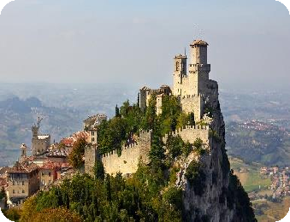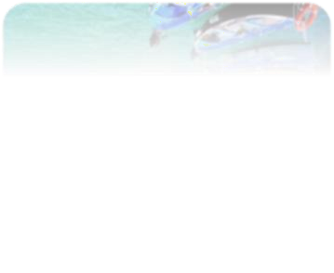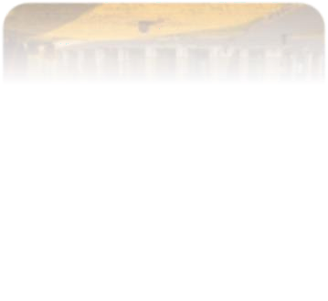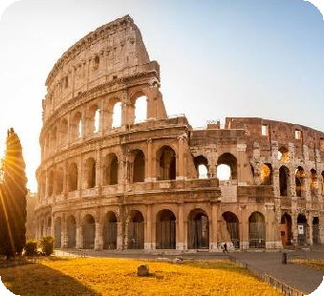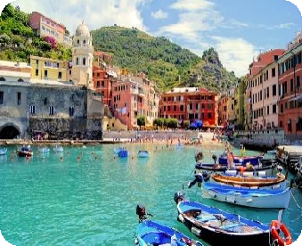

|  |  |  |
| --- | --- | --- |
| **Day 02** | **ROME – PISA (B/-/D)** | **(Colosseum)** |
|  | Breakfast at The Hotel |  |
|  | Rome sightseeing without guide |  |
|  | View of / Photostop : St. Peter’s Basilica, Colosseum, |  |
|  | Trevi Fountain, Arch of Constantine, Circus Maximus, |  |
|  | Roman Forum, Monument Vittorio Emanuelle II |  |
|  | Lunch under own arrangement |  |
|  | Transfer to Pisa |  |
|  | Photostop at Leaning Tower |  |
|  | Dinner at Restaurant |  |
|  | Transfer to Hotel. Overnight at Pisa |  |
| **Day 03** | **PISA – CINQUE TERRE – LA SPEZIA (B/-/D)** | **(Cinque Terre)** |
|  | Breakfast at The Hotel |  |
|  | Transfer to Cinque Terre  **Entrance :** Cinque Terre National Park (inc. Card Train) |  |
|  | Lunch under own arrangement |  |
|  | Pick up at Le Vanto |  |
|  | Transfer to La Spezia |  |
|  | Dinner at Restaurant |  |
|  | Transfer to Hotel. Overnight at La Spezia |  |
| **Day 04** | **LA SPEZIA – SAN MARINO (B/-/D)** | **(Guaita)** |
|  | Breakfast at The Hotel |  |
|  | Transfer to San Marino |  |
|  | Lunch under own arrangement |  |
|  | San Marino orientation tour. Pass by / Photostop : Cesta |  |
|  | Tower (De la Fratta), Piazza della Libertà, Palazzo |  |
|  | Pubblico, Museo di Stato, Chiesa di San Francesco, |  |
|  | Guaita |  |
|  | Dinner at Restaurant |  |
|  | Transfer to Hotel. Overnight at San Marino |  |

# Day 05 SAN MARINO – VENICE ISLAND (B/-/D) (Doge’s Palace)

Breakfast at The Hotel Transfer to Venice

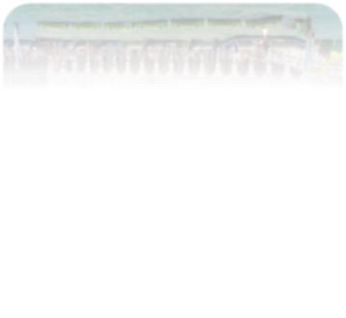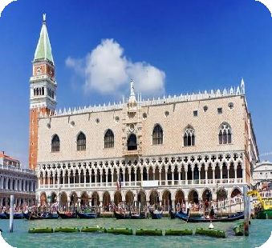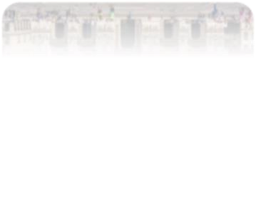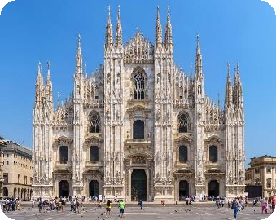

**(Duomo Milan)**

# Return boat to Venice Island with English Speaking Assistance

View of / Photostop : Doge’s Palace, St. Mark Square, St. Mark Square, Bridge of Sighs

Lunch under own arrangement Dinner at Restaurant

Transfer to Hotel. Overnight at Venice

# Day 06 VENICE – MILAN (B/-/D)

Breakfast at The Hotel Transfer to Milan

Lunch under own arrangement

Milan orientation tour. Pass by / Photostop : Duomo Milan, Sforza Castle, La Scala Theatre, Galleria Vittorio Emanuelle II, San Siro Stadium.

Dinner at Restaurant

Transfer to Hotel. Overnight at Milan

# Day 07 MILAN – DEPARTURE (B/-/-)

Breakfast at The Hotel

One way transfer from Hotel to Airport End of services

# Hotel –

|  |  |  |  |
| --- | --- | --- | --- |
| **Hotel Name** | **City** | **Rating** | **No . Of Nights** |
| Excel Roma Montemario or similar | **Rome** | 4* | 01 |
| Tower Inn Pisa or similar | **Pisa** | 4* | 01 |
| NH La Spezia or similar | **La Spezia** | 4* | 01 |
| Best Western Palace Hotel San Marino or similar | **San Marino** | 4* | 01 |
| Holiday Inn Marghera or similar | **Venice** | 4* | 01 |
| Grand Milano Malpensa or similar | **Milan** | 4* | 01 |

* **Package Inclusions**
* 06 Nights accommodation at Hotels specified in the itinerary or similar.
* 06 Buffet Breakfasts.
* 06 Dinner ( No Pork / 3 Course Local / 5 Dish Chinese menu )

# Service of Long Distance coach as per the flow of itinerary

* FOC as per the slab.

# Package Exclusions :

* Early Check In and Late Check Out charges.
* Optional and Add-on tours unless mentioned otherwise.
* Porterage at The Airport
* Any High Season Surcharges / Peak Season Supplements etc.
* Any Airfare
* Visas
* Travel Insurance
* City taxes at the hotels
* Mandatory tips to coach drivers, guides & discretionary tips to waiters or any other local services.
* Anything not specifically mentioned in the “Tour Price Includes” column.

**Child Policy :** Infant ( 0-2.99 yrs) FREE

* + Child (3-7 yrs ) sharing room with 02 full paying adults without extra bed 55% of adult cost.
  + Child (8-11 yrs) sharing room with 02 full paying adults with bed 70% of adult cost.
  + Child (12-16 yrs) will be treated as an adult sharing room on triple occupancy depending upon Hotel policy.

# Important Notes : -

* Rates are valid for 72 hours
* Rates are nett and non - commissionable
* Rates do not include surcharges applicable during Trade Fairs / Peak Season / Public Holidays

/ Festivals.

* Hotels, rooms and services are subject to availability at the time of booking.
* **Standard Check In time for Hotels:** 1400 Hrs & **Check Out time:** 1100 Hrs
* Kindly note the quote is not valid during black out dates/fair period**.** During this time we reserve the right to charge a supplement and/or offer hotel outside the city limits.
* We may arrange the meal at hotel or restaurants .